Ideation Phase

Brainstorm, Idea prioritization
Date | 30/10/2025
Time id | NM2025TMID07740
Project name | Streamlining Ticket Assignment for Efficient Support Operations
Maximum mark

Ideation Phase
The Ideation Phase focused on generating innovative and practical solutions to improve the efficiency and accuracy of the ticket assignment process within the support operations workflow. Building upon the insights gathered during the problem identification and research phases, this stage aimed to explore multiple ideas that could address the key challenges—such as delayed response times, uneven workload distribution, and lack of automation in ticket routing.
Step 1: Team Gathering, Collaboration and Select the Problem statement

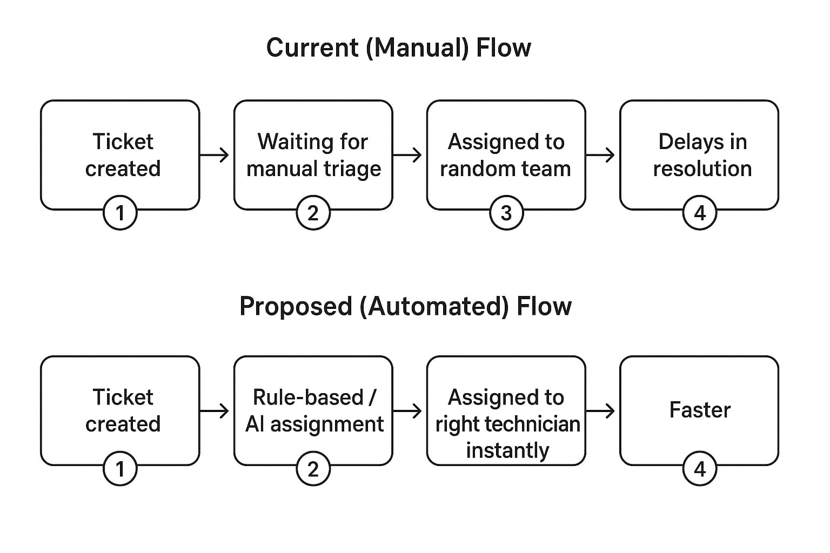
Step 2: Brainstorm, Idea Listing, Grouping
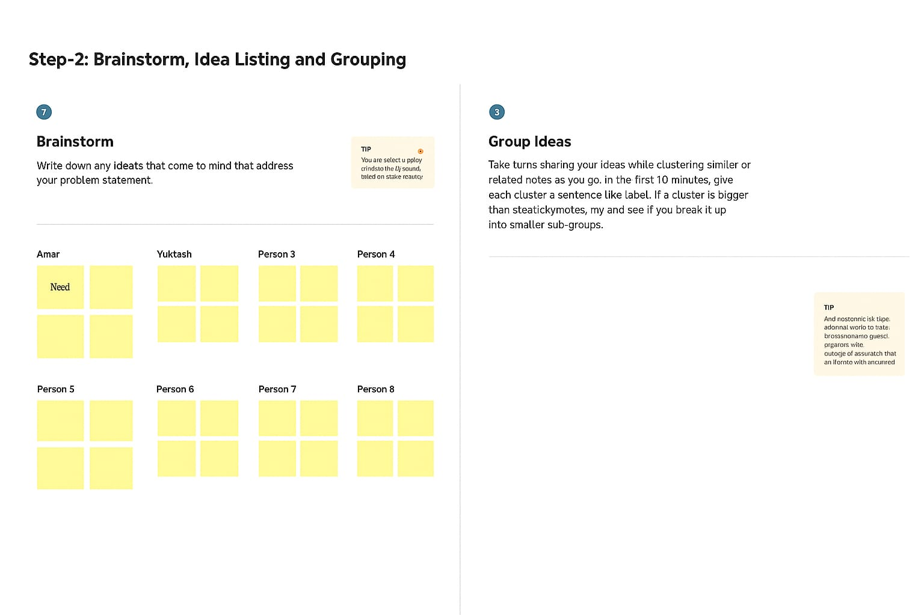
Step 3 : Idea prioritization

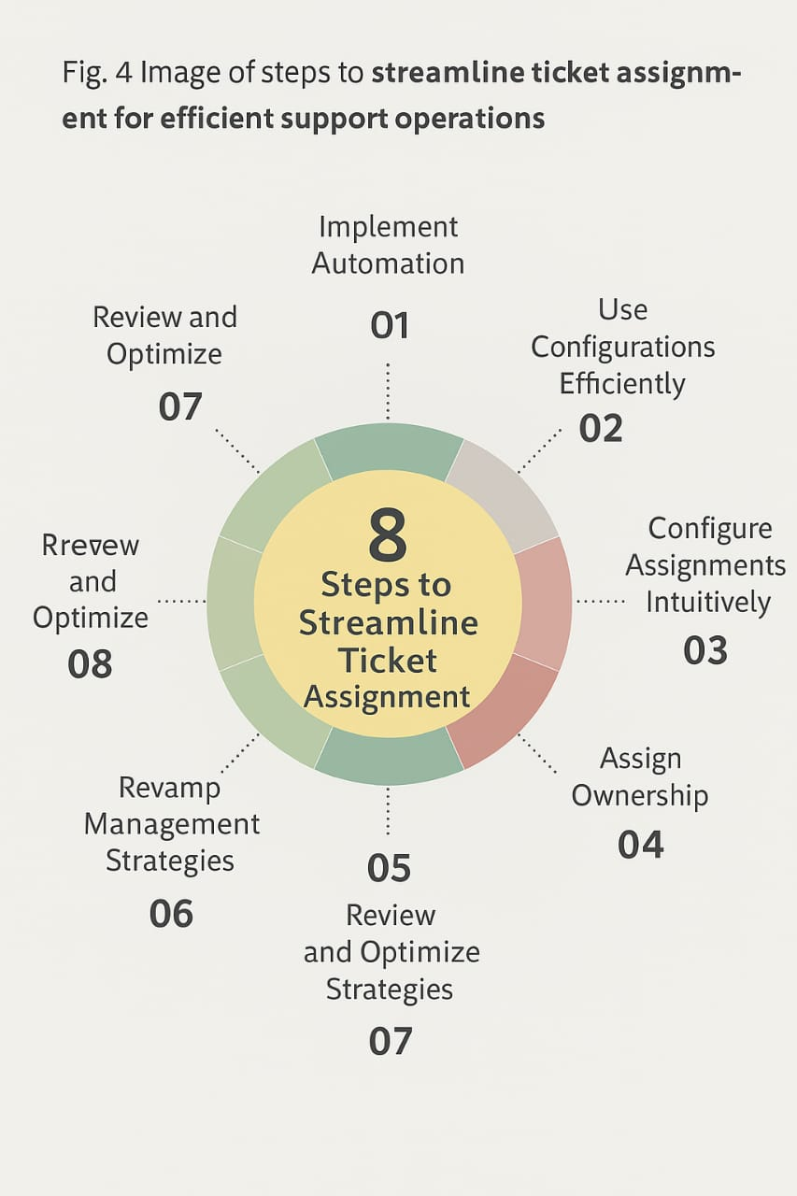

During the idea prioritization stage of the Streamlining Ticket Assignment for Efficient Support Operations project , all proposed ideas were evaluated based on feasibility, impact, cost, and implementation time. Each concept—such as automated ticket classification, intelligent routing, and workload balancing—was scored using a prioritization matrix. The team focused on selecting ideas that offered maximum efficiency gains with minimal complexity. After analysis and group discussions, the intelligent routing algorithm and automated classification system were identified as top priorities. These ideas were chosen for their potential to significantly reduce response times and optimize support workflows.

